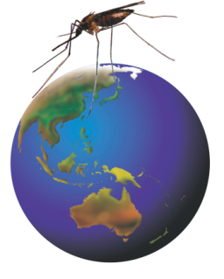

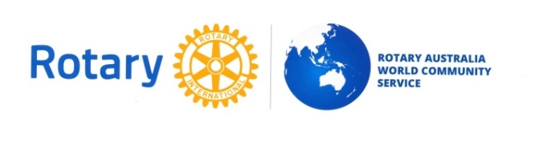
Rotarians Against Malaria
Chairman’s Newsletter
RAM

April 2016
G’day RAM representatives and friends, this newsletter provides a timely snap shot of the progress RAM is making in our programs and planning in the lead-up to Malaria Awareness Day on 30th April. Thanks for all your efforts to raise awareness and funds through our Rotary organisation. We are making a difference!

RAM PNG.
The following is an up-dated review of RAM work completed in PNG in the past few months prepared by Project Manager Tim Freeman:-
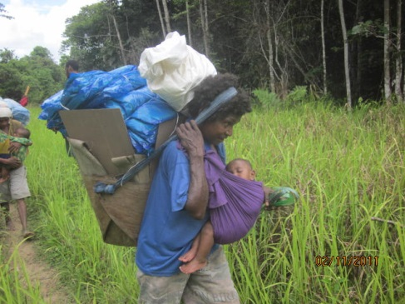
RAM PNG has appointed Regional Coordinators to improve recording and reconciliation of nets distributed to vulnerable groups such as new mothers. The coordinators will also travel with fresh stocks of RDTs (Rapid Diagnostic Test kits) and ACTs (Artimisinin combination therapy drug treatments) to ensure that clinics do not experience ‘stock-outs’. Regular distributions of Global Fund LLINs continues.
The Chasing Malaria program is progressing with recording sheets being updated in remote clinics to include details of where a patient, who has returned a positive RDT, has been in the previous three weeks. Observations of the performance of Clinic staff show steady improvements in diagnosis and recording good data but the rates of positive RDT results are still suspiciously high and warrant further investigation.
The Private Sector Retail program is progressing and sales of LLINs and Mosbar has been targeted in villages where the Chasing Malaria program has reported higher rates of infection. Mosbar in particular has been very popular in these areas and works well. A National advertising campaign for the retail LLINs and Mosbar supplied by RAM PNG has been prepared.

RAM Solomon Islands.
Project Manager Wayne Morris has been accumulating documentation on Government guidelines for the Healthy Villages project, including the village training manual. We are awaiting up to date reports and photos of recent works completed by recipient villages before progressing the Global Grant application. At this stage the 30 approved villages on Malaita Island will be targeted for this funding.
Timor Leste
Contact has been restored with the Timor Leste National Malaria Control Program (NMCP). They have sent us a detailed list of the distribution, by health district, of bed nets for expectant mothers supplied by RAM last year. Also, in response to my enquiries, as to how RAM might continue to assist, they have proposed that we could help by funding the distribution costs of nets supplied by the Global Fund. Apparently the latest Global Fund grant relied on the Timor Leste Government to fund the distribution and they apparently have a budget short fall.
The NMCP request is :-
“National Malaria Control Programme has received 250,000 Long Lasting insecticide treated nets (LLINs) funded by Global Fund to distribute at the rate of 1 net per two people who live in malarious areas. These 250, 000 will protect nearly 500,000 malaria at risk population in the country after the distribution.
We have a shortage of funds to distribute LLINs to risk population in 2016. The districts, target quarters and no of LLINs need to be distributed is shown in below mentioned table.
District | Ainaro | Aileu | Baucau | Bobonaro | Liquisa | Lautem | Manufahi | Manatuto | Dilli
Target Qtr | Q1 | Q3 | Q1 | Q2 | Q2 | Q2 | Q2 | Q2 | Q3
Target-No of LLINs | 23797 | 21950 | 41758 | 22951 | 42583 | 35837 | 26668 | 19895 | 48119

The total budget needed is 121,435 US$ (0.54 $ per net for distribution) for distribution in 9 districts. We will very much appreciate if the RAM can fund for distribution of nets. The most needed and risk districts are Bobonaro (boarder migration), Baucau and Liquisa districts.”
RAM is seeking more information about this request and considering how some of the proposed distributions could be funded in a transparent manner, perhaps involving Rotary Volunteers on the ground to assist and monitor.

RAM PhD Student Edgar Pollard.
Edgar reports:- “Since returning from my initial pilot field trip in January to the Solomons I have been spent most of my time behind at the desk working on a literature review and also on my proposal toward confirmation. The trip in January was to visit the villages that will be my study sites and to also spend time practicing the techniques. I have given a couple of talks on my project, one to Cairns Southside Rotary and another open talk to JCU staff and students.

I have still been collecting mosquito's at a local site that has good numbers of An. farauti and been working on optimization of my barrier fences looking at which shading thickness and colour the mosquitoes are preferring to rest on. By the end of April we hope to have finalised out barrier fence design and to also have spent a few nights at Cowley Beach Army base collecting mosquitoes with the Australian Malaria Institute.”

Rotary Ride Around Australia Against Malaria RRAAAM
Steve and Doreen are continuing to investigate how the RRAAAM funds could be used to assist in eliminating malaria from Tanna Island in Vanuatu. They have run into some minor blockages due to local politics but are continuing to progress their planning and considering the scope of an MOU to be agreed with the Vanuatu Government.

Rotaract’s National Malaria Project.
Rotaract have set April as “Malaria Month” and through their National Project “Rotaractors Against Malaria” are running a crowd funding campaign all month with the goal of raising $14,000 for RAM. The following is part of their media release:-
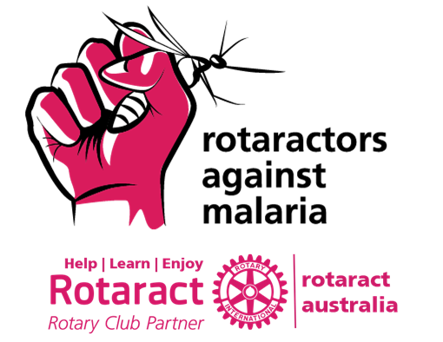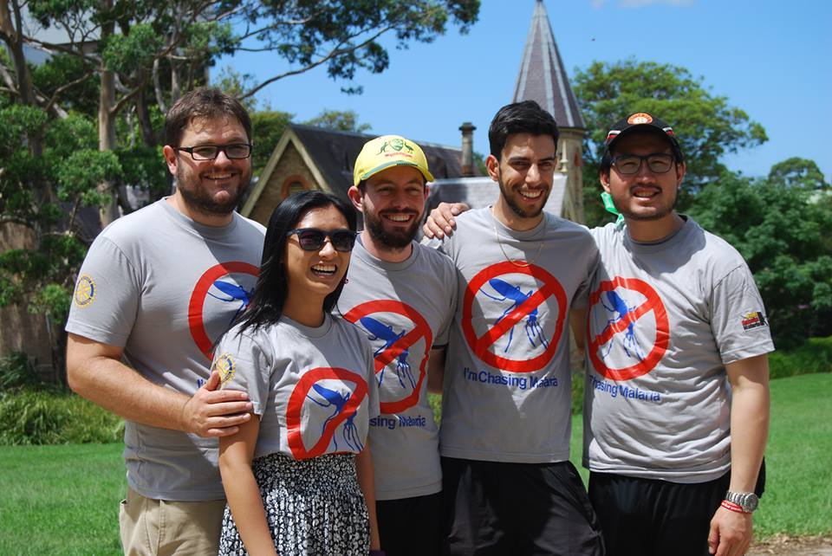
“Since 2013, Rotaract Australia's national project, Rotaractors Against Malaria, has raised over $11,000 towards malaria prevention in our nearest at-risk neighbours, PNG and the Solomon Islands. Historically Papua New Guinea has one of the highest burdens of malaria outside of Africa. Annual incidence rates were about 300 per thousand people before Rotarians Against Malaria, a RAWCS project, started distributing treated bed nets in PNG. Since the project started, clinical malaria incidence has fallen by as much as 70% following a distribution by nets in a district. Despite this progress, malaria is still a leading cause of death in children under 5 in these regions. PNG has had its funding from The Global Fund reduced so therefore the RAWCS project cannot continue to distribute nets to all households in PNG. Now is a chance for Rotaractors to demonstrate the power of our community to influence for change and direct sources towards elimination malaria in our region.

This month, in the lead up to World Malaria Day in Australia on 30th April, Rotaract Australia are running a fundraising campaign, MALARIA MONTH. Rotaractors are pledging to give up an unhealthy habit to raise a target of $14,000 for projects such as "Chasing Malaria" in PNG and "Healthy Villages" in the Solomon Islands.
Support us in the global fight to eliminate malaria and donate at http://malaria.rotaract.org.au/ . Follow our campaign on social media with the tags #RotaractorsAgainstMalaria and #RotaractAustralia.”
To assist Rotaract we have registered a new RAWCS Project (Number 54/2015-16) so that donors can receive tax deductable receipts, donations can be tracked and the net proceeds transferred to RAM. I am aware that several District RAM Chairs are supporting Rotaract in this campaign most notably Vernon Brown in D9570, where Rockhampton Rotarians have already contributed $1,000 to the campaign.

Malaria Awareness Day.
Malaria Awareness Day is 30th April and Rotaract and some district Chairs are making April Malaria Month in order to raise awareness and focus fund raising. We will have a session at this year’s conference on planning for a coordinated National campaign in the lead-up to MAD in 2017.

RAM Logo and printing.
A new RAM leaflet has been prepared in a style format that is consistent with RAWCS promotions. The leaflet has been printed and is being sent to all Regional Coordinators this week. New supplies of the orange Malaria Awareness Day leaflet have also been printed so if you need more contact your Region Coordinator or Belinda Griffin at RAWCS.
It seems that the RAM logo of the Anopheles mosquito on the Globe is still OK provided it does not include the Rotary wheel. So for now, until someone comes up with a better one, we will use it in conjunction with the new RAWCS logo as seen at the head of this newsletter and on the new leaflet.

Promoting the malaria cause within Rotary International.
I have prepared a briefing paper outlining the current state of the Global campaign to eradicate malaria, the role that RAM has played and the potential for Rotary international to play a very significant part in the future once we have declared Polio eradicated and there is a viable vaccine that could be used for mass vaccinations in endemic areas as part of a strategic approach to eliminating malaria region by region. The paper has been sent to incoming RI board member PDG Noel Trevaskis and RI President elect PDG Ian Riseley. We also plan to use it in a modified for as part of an increasing lobbying of the RI board and staff to ensure that malaria is given informed consideration in the behind the scenes planning for Rotary post Polio.

Conferences
Make sure you put the RAM Conference dates in your 2016 Diary. The conference will be held at Ciloms Airport Lodge near Tullamarine (Melbourne ) airport on 20th and 21st August 2016.
As noted in the last newsletter the ‘International Congress for Tropical Medicine and Malaria 2016 (ICTMM 2016)’ is on from 18 - 22 September 2016. Details are at http://tropicalmedicine2016.com/ .. In the meantime they are holding a launch in Brisbane which will take the form of a breakfast this Friday 15 April 2016 at 8:00am, hosted by the Honourable Dame Quentin Bryce AD CVO, the former Governor-General of Australia.
There will be a panel discussion on “Mobilising to Defeat Malaria, Tuberculosis and HIV/AIDS in our Region and Globally: Challenges and Achievements” Moderated by Dr Norman Swan, Host, ABC RN Health Report. RAM Funding Coordinator, Richmond Manyweathers and D9630 RAM Chair John Paskin will attend and report back.

David Pearson :
National Chairman RAM, 14th Feb. 2016.

