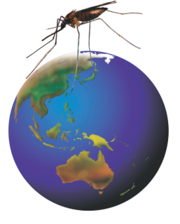
Rotarians Against Malaria

National Manager’s Newsletter
November 2016

RAM - A volunteer-run organisation working to eliminate malaria

I guess you have all heard that the 2015 Nobel Prize for Physiology or Medicine was awarded to Tu Youyou for her pioneering work on the current frontline malaria drug Artimisin. But did you know that the same Nobel prize in 1902 was awarded to Dr Ronald Ross who demonstrated the life cycle of the malaria parasite in mosquitoes and that the 1907 Nobel prize was belatedly awarded to Dr Charles Laveron who in 1880 had first recognised that malaria was caused by a parasite in human red blood cells. These and all sorts of other interesting insights can be found by googling the following link: https://en.wikipedia.org/wiki/Malaria .
The time since the RAM Conference in August has flown by and lots of action has been taking place. Our front line project managers have been very busy and in both PNG and Solomons they have secured additional sponsorship to accelerate or deepen the program reach.
RAM PNG.
As the Principal Recipient for the Global Fund Grant and a member of the Country Coordinating Mechanism, RAM PNG has the main responsibility for procuring and delivering LLINs as well as developing plans and strategy for dealing with malaria in the future. Since 2009 RAM PNG has delivered 8.27 million nets including 650,000 since the start of 2016. Just over 100,000 nets have also been distributed to vulnerable groups in 2016 of which 80% have been to new mums.
Under the Global Fund’s current grant, which runs until the end of 2017, reduced funding has meant that some high altitude and urban areas were not to receive household distributions or that new nets were only distributed to families with kids under 5 years old. In the case of the under 5’s distributions the nets were big enough for four family members to sleep under.
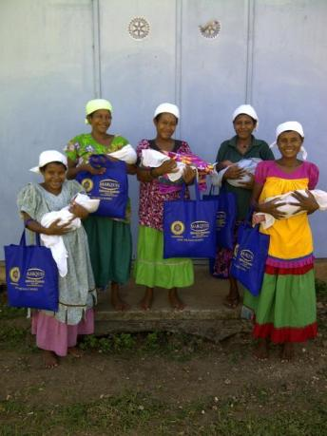
Recently RAM PNG has secured assistance from the Oil Search Foundation (US$60,000), Exxon Mobile (US$25,000) and Against Malaria Foundation (1.15 million LLINs) that will reduce the impact of the Global Fund budget compromise and enable more universal household net distributions, at least for the next 12 months. Great work Ron, Tim and all the RAM PNG team!!
It should also be acknowledged that RAM continues to work closely with the PNG NDoH, Church groups and other NGOs to achieve net distributions and accurate accounting in very challenging conditions. The current all up cost of a delivered net, averaged across the country is US$6:80 per LLIN.
As the Principle Recipient (PR) for the Global Fund, RAM PNG has also been charged with developing a National Malaria Plan. This document has required wide consultation since 2014 and is nearly complete.
The Chasing Malaria program continues with RAM teams helping local people in Central Province and NCD to develop site specific programs to deal with local malaria outbreaks. This closely monitored program has highlighted that there are still problems in remote clinics with accurate data recording and that there is currently a massive shortage of antimalarial drugs provided by the NDoH.
RAM Solomon Islands.
Solomon Islands Coordinator PDG Wayne Morris has reported that funds sent to the Solomons in late 2015 were used to provide 22 villages in the Russell Islands (NW of Guadalcanal) with tools to assist in removing mosquito breeding grounds and improving village hygiene. A further $30,000 has been sent recently which includes $25,000 raised in D9820 by Christine Williams DG’s partner project. Wayne has also secured funding from the Solomon Forest Association, who have pledged $16,000 PA for the next three years and the Malaysian high Commission in Honiara who raised $45,000 through a charity golf day. These funds will enable most of the currently accredited villages to receive tools and give confidence to the Health Promotions Department of the MoH to further extend the program.
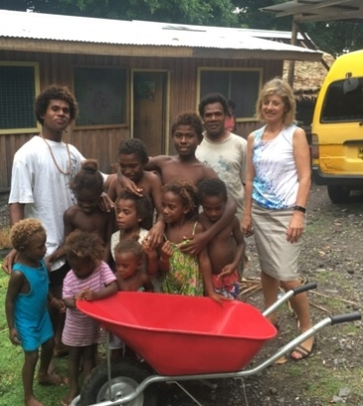
In early November D9820PDG Merv Williams, Christine and I travelled to Honiara and along with PDG Wayne we had meetings with Solomons MoH staff, and the Australian High Commission to highlight RAM’s ongoing commitment to eliminating malaria and to explore opportunities for further contributions to the current programs as well as opportunities for Rotary Volunteers to be involved. Whilst there we also met with WEHI researchers Assoc. Prof. Harin Karunajeewa and Dr Robert James who were in town setting up an 18 month malaria trial at Tetere where there is a concentrated population from all over Solomons working on the Palm oil plantations. We visited the clinic there and observed an average day of about 30 malaria tests (both microscope and RDT) for about 6 confirmed cases. There is also a possibility for RAM to assist this research project and perhaps to involve future volunteers.
During our visit we inspected a storage shed built in 2009 as a RAM project to support net distributions and found it in good condition. Christine and Merv were also able to visit villages on Guadalcanal that had received tools through RAM’s support for the Healthy Villages program and speak with some very happy and grateful locals.

Award for PDG Wayne Morris OBE.
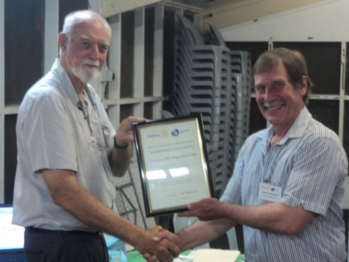
RAM started as a project in 1995 as a cooperative venture between then D9680, at the urging of Dr Brian Handley, and a committee formed in the Rotary Club of Honiara D9600. During this formative period Wayne Morris was President of the Honiara Club and his then business partner Chris Bowman was on the committee. Since the start Wayne has been a constant supporter of RAM and other RAWCS activity in the Solomons and has facilitated many projects through his business. Wayne has promoted RAM widely, including during his time as D9600 Governor, and has enabled RAM to stay relevant through numerous political developments as well as securing outside funding streams for some of RAM’s work.
In recognition of this 21 year commitment it was my great pleasure to present Wayne with a RAWCS Humanitarian Service Award on 31st October in Honiara.
RAM PhD Student Edgar Pollard.
RAM Chair for D9710 John Macpherson recently asked Edgar to record a short video describing his research so that John could include it in his presentation at the D9710 Conference. This was very well received along with a similar video produced by Dr Danielle Stanisic regarding the vaccine development. Please let me know if there is interest in other districts in having these available for presentations.
RAM Timor Leste
RAM’s commitment to assist the Timor Leste NMCP with funding for LLIN distribution will be used to distribute nets in the Oecusse enclave in January or February 2017, depending on weather conditions. RAM is also funding a new program being developed by RC Dili Lafaek to implement a “Healthy Villages” project in Dili and Liquica districts. The proposal encompasses Community health and hygiene awareness training, establishing Community Committees, planning health interventions and building permanent rubbish disposal facilities, aimed at reducing mosquito breeding as well as improving hygiene.
PDGs Phil Dempster and Ian Dyball have been corresponding with RCs Dili and Dili Lafaek as well as the RAWCS office in Dili to help set up the new project. It had been hoped to send a team of Rotary Volunteers to assist in early November but this had to be cancelled due to withdrawal of the Team Leader. We now expect to send several teams in April 2017 and a list of Volunteer expressions of interest has been compiled.
Malaria Vaccine Development
RAM has endorsed RABS Project 16 / 2016-2017 which has been registered by RCs Southport and Broadbeach D9640, to cover a Rotary Zone wide fund raiser to support the Clinical trials of a promising malaria vaccine being developed by the Institute for Glycomics at Griffith University. PlasProtecT® is a novel malaria vaccine candidate. It comprises whole malaria parasites that are grown in the laboratory and are then treated so they can no longer replicate or cause infection. As a result, when the vaccine is administered, the immune system is raised without causing disease.
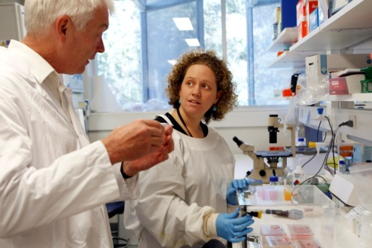
The vaccine development has already included several trials which tested it’s safety in humans and apparent efficacy in inducing immunity. The next stage involves clinical trials with a larger human sample from a non-endemic country (Australia) with a control group. This will assess whether the vaccine actually works; that is, will PlasProtecT® protect people from malaria infection?
As Dr Danielle Stanisic, Senior Research Fellow and a member of the Satellite Rotary Club of Southport, remarked: “This stage of clinical trials is critical. Positive results will facilitate further testing in endemic countries like Africa, Indonesia or Papua New Guinea.” [Danielle is pictured in the lab with Prof. Michael Good]
Annual RAM Conference
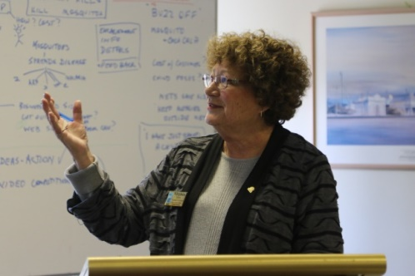
The annual RAM Conference was held in Melbourne (20 -21st Aug) with a pleasing 58 delegates registered but representing only 12 of our 21 Districts. There was a great attendance from the Southern Region Districts, including many Rotarians attending for the first time and pleasing feedback was received from both invited speakers and participants. A complete report on Conference proceedings has been posted on the RAM web site. A short article has also been published in RDU. [Pictured is National Secretary Virginia at the Conference.]
The RAM Executive is currently considering whether the 2017 Conference should be held in Sydney.

Malaria Awareness Day.
Proposals for a National Malaria Awareness Day (MAD, 30th April) project were workshopped during the recent RAM Conference. What is currently proposed is to encourage Rotary Clubs to promote the danger of the mosquito (most dangerous animal on earth) as a lead-in to raising awareness about malaria in conjunction with a major outdoors market retailer. We have in mind sausage sizzles (coordinated between the major retailer and local Rotary Clubs) as a base for general information about mosquito borne disease on Sunday 30th April supported by catchy slogans such as “Beat the Bite”, eye catching displays, a little theatre and handouts. Whilst these ideas were enthusiastically developed at the Conference it has proved to be difficult to establish a committee to coordinate a nationwide approach. If anyone would like to get involved with progressing this concept please contact me directly. In the mean time I encourage all District Chairs to plan how Malaria Awareness Day can have impact within their Districts this coming April.
Similarly proposals for a National Competition for school kids to produce a short video on Malaria and mosquitoes have been pared back to an initial trial involving several Districts in Southern Region commencing when schools resume in 2017. We hope that this trial will be developed into a National Competition in the following year.

RAM and Rotaract’s National Malaria Project.
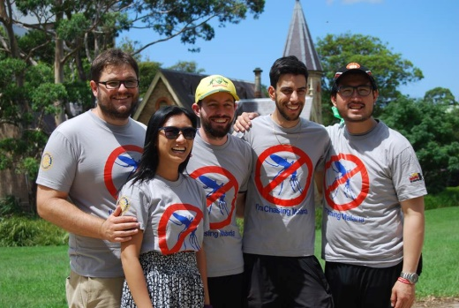
I am pleased to report that two of the main players in Rotaractors Against Malaria, the national project of Rotaract Australia have agreed to join the RAM Executive Committee. Past National Chairman of Rotaract Australia, Michael Shields has accepted the position of Rotaract Liaison Coordinator and current PR and Marketing Director for Rotaract Australia, Holstein Wong, has also accepted the position of Publicity and Media Coordinator for RAM.
Michael, with the yellow hat and Holstein, with the sunglasses are pictured here at last year’s National Rotaract Conference. Holstein is currently working on up-grading RAM’s website to make it phone and tablet friendly and better integrated with the RAWCS site. Both Holstein and Michael have taken over the RAM Facebook page Editorial roles from Jess Main and Roshni Thattengat, who originally created it for RAM.

Rotary International and Malaria
In the November issue of RDU Magazine Rotary Foundation Trustee Chairman Past RI President Kalyan Banerjee calls on all Rotarians to mark and celebrate the Rotary Foundation’s centennial by undertaking activities that “do good in the world”. Among his suggestions he includes “tackling malaria” which I believe is a good indication that the Foundation leadership is on the same page as RAM.
Part of our strategy for convincing RI of the importance of taking up the malaria challenge following the defeat of polio is to keep this idea front of mind for all the Rotarians that we have a chance to speak with. RI, with all the global immunisation experience gained through PolioPlus will be very well positioned to do tremendous “good in the world” by being a major player in malaria when we have a reliable vaccine and new drugs to clean out dormant parasites without the current side effects.

New RAM District Chair
For several years we have been seeking to appoint a RAM Chair in D9830 which comprises the State of Tasmania. I am delighted to announce that this position has recently been taken up by Jenny Kerrison a member of RC Hobart Nth. Jenny brings a great depth of experience in Nursing in West Timor and other parts of Indonesia and also is Project Manager for a RAWCS project in Bangladesh. She has expressed a keen interest is joining Rotary Volunteers teams and speaks Bahasa, which will be useful in Timor Leste.

For any RAM related enquiries please contact:
Dave Pearson: dave@sugarloafne.com or Virginia Turner: vm.turner@bigpond.com

RAM is a National Activity of RAWCS
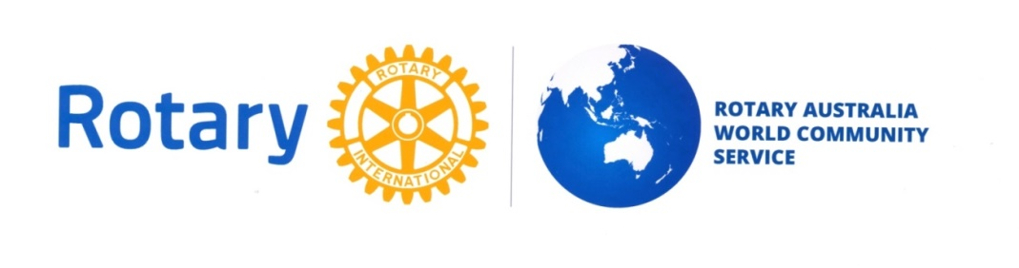
David Pearson :
National Manager RAM, 10th November 2016.

