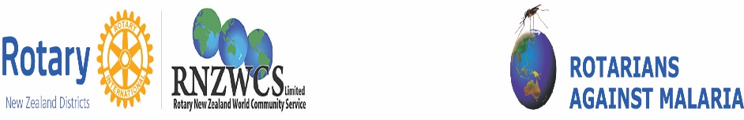

**OVERVIEW OF ROTARY GLOBAL GRANT – “END MALARIA IN VANUATU – FOR GOOD”**

With a lot of work put in by RAM National Staff the “End Malaria in Vanuatu – For Good” Global Grant was submitted at the end of June 2020. The four Southern Region Districts involved were D9790, D9800, D9810, D9820 and District 9910 in New Zealand. New Zealand’s PDG Lindsay Ford (D9910) is managing the Project.

The Project will train Trainers for their National Indoor Residual Spraying Program (IRS) and provide IRS equipment and insecticides to the IRS Teams in two Provinces that are Malampa and Sanma. The total value of the Grant is USD111,02.00. Money raised was through the generous donations of DDFs from five Districts, contributions paid into the Southern Region RAWCS Fundraising Account and one third of what was required was funded by RAM itself. Our contribution is vital to malaria elimination in Vanuatu.

**\*We REALLY NEED your help to continue and extend this worthwhile Project in the near future and would** **greatly appreciate your contributions** **via**: <https://donations.rawcs.com.au/104-2019-20>

Where are we now?

The vital first step, the Geographical Reconnaissance Baseline Household Mapping will take place in April. This activity is being funded by RAM.

Once the mapping is completed then our Rotary Grant will commence to take effect. The mapping data and the fieldwork will provide critical information for the training and IRS implementation in the selected provinces.

April will work well, for Rotary Grant commencement with training and the procurement of the required materials (sprayers, insecticides and personal protection equipment). The spraying of houses in the two provinces will begin in May

We await further progress reports

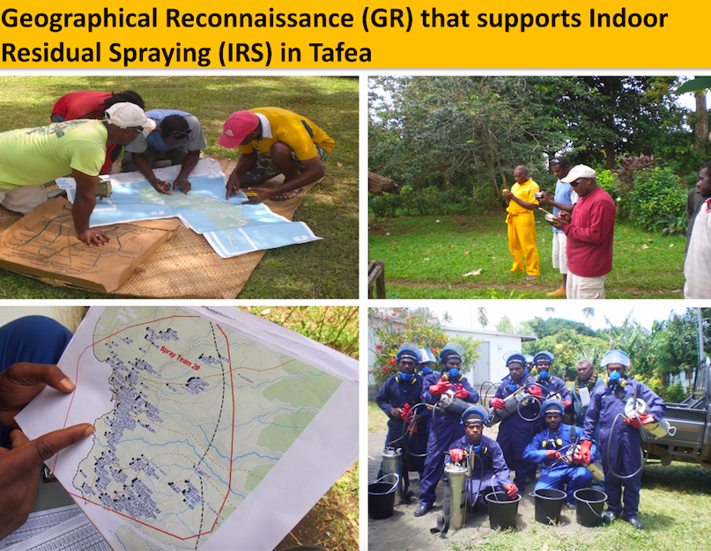

Vanuatu National Vector Borne Disease Control Program

Report written by Southern Region RAM Coordinator Gloria Hargreaves with input from National RAM Manager Dr Jenny Kerrison