PR and Media Quarterly Report

**FEBRUARY**

*Netania Lim (*[*rampr@ram.rawcs.com.au*](mailto:rampr@ram.rawcs.com.au)*), 13 February 2020*

Thank you to everyone who’s been following, liking, commenting, sharing RAM’s content recently. Please send through photos and stories so we can share them on the RAM website and social media.

Key achievements in this quarter include:

* Updating the website with anew homepage, blog and MAD content, and since last meeting’s decision, a new members only area
* Advising District Supervisors on how they can assist RAM PR and Media, and how RAM PR and Media can assist them
* Brainstorming and organising the MAD campaign activities and social media campaign

MAD campaign announcement:

Malaria Awareness Day is on 30 April 2021. We have not announced a theme yet, but we are keen to host a country-wide fundraising event, so we have proposed a virtual fun run (see attached document). The website page is also available here: <https://ram.rawcs.com.au/malaria-awareness-day/>. The virtual fun run page is here: <https://ram.rawcs.com.au/funrun/>.

The below document is the main document regarding MAD:

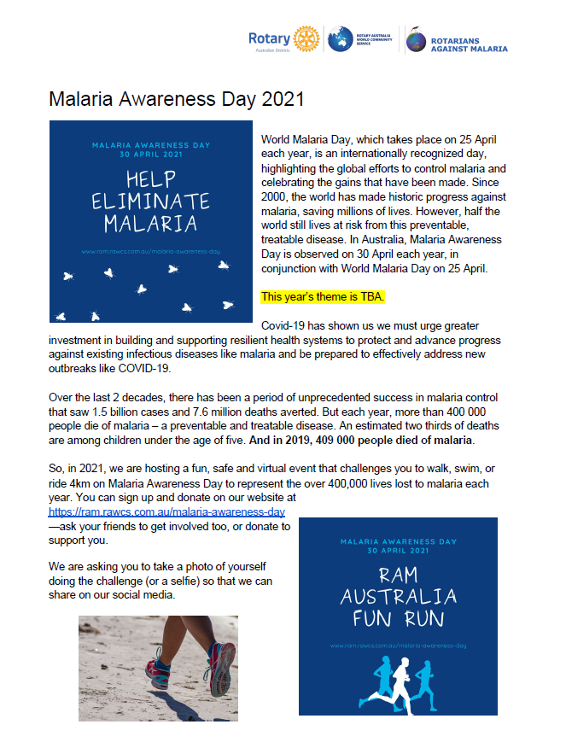

Social media achievements:

* Consistent and branded posts
* Greater engagement and reach over the past quarter
* Planned and strategic approach
  + [Facebook](https://www.facebook.com/ram.australia/) - <https://www.facebook.com/ram.australia/>
  + [Instagram](http://instagram.com/rotarians_against_malaria_aus) - <http://instagram.com/rotarians_against_malaria_aus>
  + [Twitter](http://twitter.com/ramalaria_aus) - <http://twitter.com/ramalaria_aus>
  + [LinkedIn](https://www.linkedin.com/company/rotarians-against-malaria-australia) - <https://www.linkedin.com/company/rotarians-against-malaria-australia>
  + Youtube - <https://www.youtube.com/channel/UCUhhiFMHE1NUWGx_t-1MiaQ>

RAM website updates:

1. New members only area - To exist as the Executive Committee’s document depository (similar to how Google Drive or Dropbox would work). This will have a unique login for each individual RAM member to ensure maximum security. We hope the new website will be launched by March, and we hope the Executive and Supervisors will be able to give us feedback.
2. Homepage - The homepage has been updated to suit our current needs and improve user experience. We are updating several other pages and consolidating some to improve the member experience as well. Please give us any feedback.
3. Blog - As always, we are requesting stories and images for the RAM blog on our website and for our social media. Ideally, we would like at least one story from each region every year. There are more examples here: https://ram.rawcs.com.au/blog/. There are some tips on how to write a blog post in the Orientation Pack available here: https://ram.rawcs.com.au/media/. Or, just get in touch and I can help you write!

Metrics:

### WEBSITE

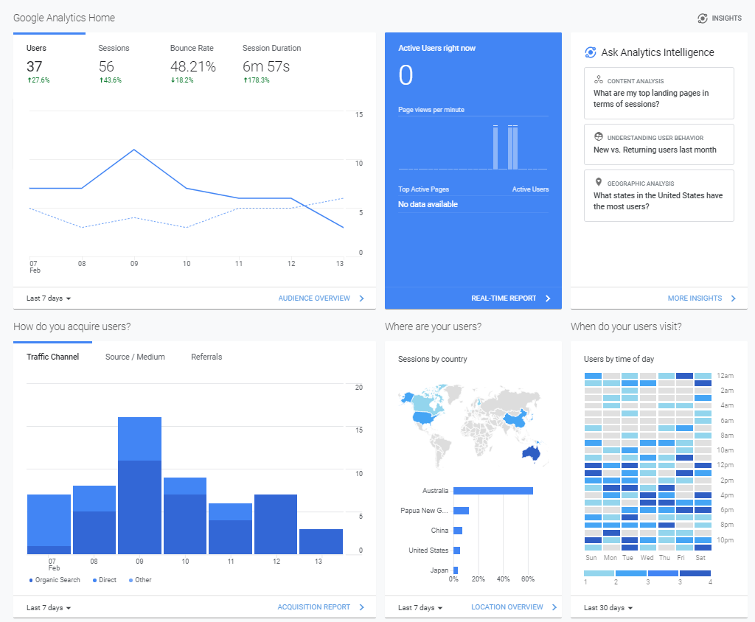

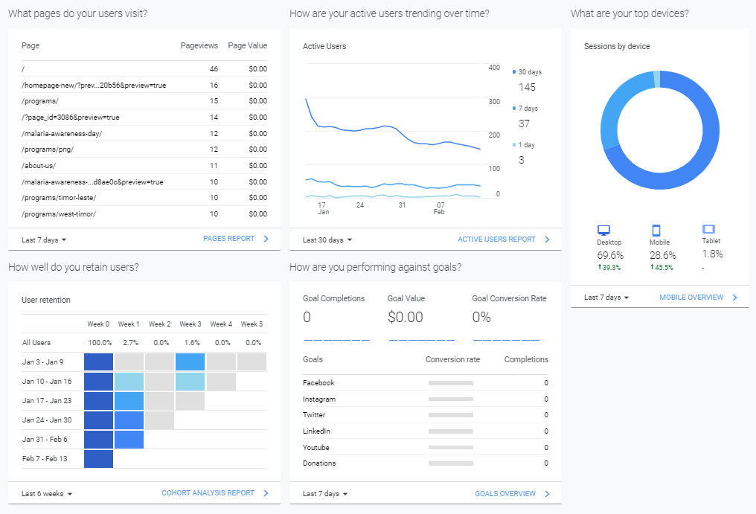

### FACEBOOK

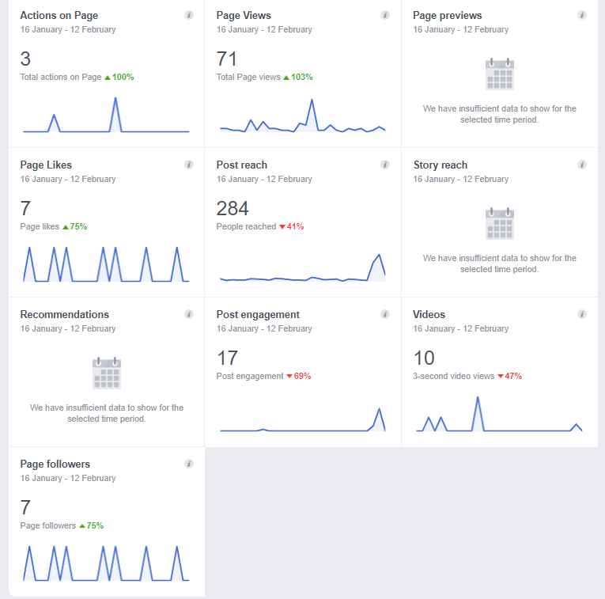

***Facebook has removed several insights as a result of EU privacy laws, which relates to Facebook and Instagram, and has recently announced upcoming changes to their algorithms to reduce the number of politics-related posts. This highlights the importance of our mailing list and our website, which is part of our 2021 strategy to improve the flows from our social media to our subscribers and website visitors.