Rotarians Against Malaria
National Annual Report for Rotary Year 2021 – 2022
Current situation in malaria elimination
Globally, malaria is one of the top 10 killers in low-income countries (World Health Organisation [WHO], 2020). Malaria kills, if not treated early. Thus, disruptions to services can lead to increased cases as occurred during the COVID-19 pandemic. In 2020 during the pandemic, there was an estimated 241 million malaria cases in 2020 with 14 million more than in 2019. One child dies of malaria every minute (WHO, 2021).
The good news is that in late 2021, the WHO announced the introduction of RTS,S (Mosquirix™) malaria vaccine for children in high burden malaria endemic countries. The RTS,S is the first malaria vaccine to prevent Plasmodium falciparum - the deadliest and most prevalent parasite in Africa. Developed in 1987, the vaccine was pilot tested in four endemic African countries in 2019. The vaccine has moderate efficacy but will save millions of children in Africa.
In 2021, most of our partner countries reported decreased malaria cases. See Table 1 below. For the first time since 2015, Papua New Guinea reported a slight estimated reduction in malaria cases. However, in the first half of 2022, the COVID-19 pandemic contributed to worsening malaria situation in Solomon Islands and Vanuatu. Other challenges common to the two countries were health systems’ challenges such as: limited number and capacity of health staff, access to remote locations, malaria commodities management, and limited financial support. Malaria deaths were reported in Papua New Guinea, Solomon Islands and West Timor (Indonesia).
Country | Annual Parasite Incidence per 1,000 population
 | 2020 | 2021
Papua New Guinea | 167 | 156
Solomon Islands | 111 | 119
Vanuatu | 1.7 | 1.05
Timor Leste | 0.01 | 0
West Timor (Indonesia) | 0.18 | 0.09
Table 1: Annual Parasite Incidence (API) in RAM’s five (5) partner countries.

Achievements for the 2021 to 2022 Rotary Year
Goal # 1: A strong RAM National Committee
RAM is the focal point for Rotarians for work on malaria control and elimination. A review of the National Committee’s roles and responsibilities is required to ensure that RAM continues to maximise on available resources and recruit where gaps exist.
Our National RAM Committee’s achievements were:
- Our RAM marketing strategy is aligned with the Rotary clubs’ (RCs) obligations for international service that is one of Rotary’s five Avenues of Service.
- A RAM visibility campaign was conducted with monthly malaria messages distributed to over 400 subscribers. More subscribers are needed to spread widely across our network.
- We held a second virtual National Fun Run / Walk on Malaria Awareness Day with some success, in end of April. Thank you to Rotaractor Netania Lim, PR and Social Media Coordinator.
- The annual RAM National Conference was held virtually due to the COVID-19 pandemic. It was successfully managed by the Eastern Region and National RAM executives.
- We have demonstrated that the “Adopt-A-Project” approach worked well in the Southern Region (SR) and helped raised an additional $13,000 for Vanuatu. See Graph 1 below
- RAM successfully sourced funding from external to our national network. See bar on far right of Graph 1 below.
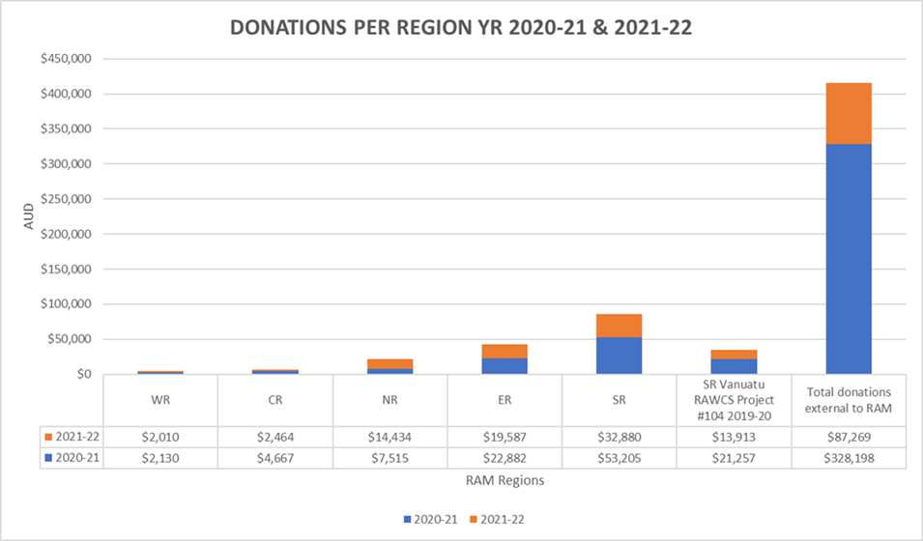
Graph 1: Donations per Region in Years 2020-21 & 2021-22
VACANCIES: RAM seeks passionate Rotarians for the following positions: (a) National Secretary; and (b) National Deputy. Recent call for nominations were unsuccessful.
Goal # 2: Strong support for malaria elimination in our partner countries
RAM provided guidance to RCs in the management of Rotary GG for our partner countries. A summary of our support is provided below.
In Papua New Guinea (PNG) (D9620), funding for the Chasing Malaria program was concluded in early 2021 year due to a lack of funds in RAM Australia. RAM-PNG is the principal recipient for The Global Fund to Fight AIDS, Tuberculosis and Malaria (GF) and provides key malaria services for the PNG Government. Between 2009 – 2021, RAM PNG successfully distributed a total of 14,320,744 LLINs in three-yearly cycles. Malaria cases increased in 2015 after a sharp decline since 2010. A contributing factor for the increase in malaria cases and deaths was the sub-standard long lasting insecticidal nets (LLINs) delivered between 2014 and 2019 (Tim Freeman, 15 June 2022).
In 2020-21, RAM Australia assisted the RC of Kippa Ring-North Lakes (D9620) in the successful application for a Rotary GG#2016222 for New Ireland Province, PNG, to establish a new intervention of Outreach Response Teams in Tikana, Kavieng. Implementation is delayed due to logistical issues.
In the Solomon Islands, malaria cases continue to increase since 2015. See Table 1 above. RAM Australia and RAM Solomon Islands will fund the malaria Active Case Detection (ACD) project that was delayed due to the COVID-19 pandemic. Implementation is planned for August 2022.
Vanuatu was progressing well with an API of 1.05 cases per 1,000 population in 2021. However, the COVID-19 pandemic has contributed to malaria outbreaks in 2022. The pandemic has caused a delay in implementing Rotary GG# 2014632, to train and equip a national indoor residual spraying (IRS) team. To date, the project has trained two Master Trainers and purchased 10 units of IRS machines and USD60,000 worth of insecticides.
Timor Leste has achieved zero indigenous malaria in 2021 and is on track to achieve WHO malaria-free status by 2025. The country’s biggest threat is cross border malaria transmission from West Timor into Oecusse in Timor Leste. The two-year GG # 2015315 to prevent reestablishment of malaria is progressing well and has purchased 5,000 nets in 2021.
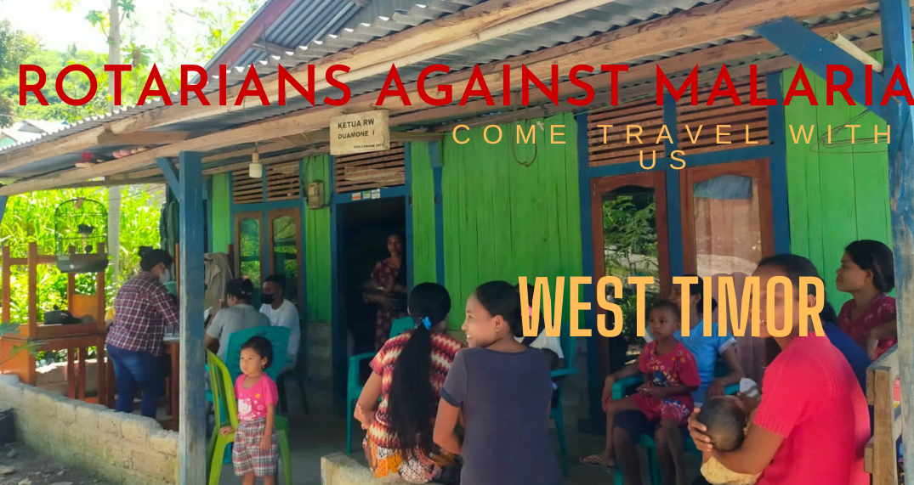
West Timor, Nusa Tenggara Timor (NTT) Province, Indonesia, shares Timor Island with Timor Leste. For the last five (5) years, West Timor has had low malaria endemicity of less than one (1) malaria case per 1,000 population. RAM is assisting the local RC of Kupang Central D3420 and RC Hillarys D9455 to implement Rotary GG #2015867. One of the key activities is to train and post Village Malaria Cadres (VMCs) in two border District, to encourage early testing and treatment of malaria. The RAM-Global Rotary Action Group has provided a top-up in funding to increase the number of trained VMCs.
Photo 1: Mothers and children gather at the monthly Integrated Health Post (Posyandu), West Timor.
Goal # 3: Position RAM as a focal point for coordination and advice
RAM Australia offers technical and practical support to Rotary clubs in all aspects of project design and management. In this Rotary year, RAM and Cross Sector Development Partnership Initiative (XSPI) with assistance from Dr. Dan Evans, Jeff Smith and several contracted consultants conducted a large scoping study in all administrative locations in NTT province and in Timor Leste. This major undertaking was funded by Asia Pacific Leaders Malaria Alliance (APLMA), Evans5 Foundation, Malaria Partners International (MPI), RAM-Global Rotary Action Group and RAM Australia.
Goal #4: Increase the pool of malaria experts in our partner countries by offering a RAM PhD Scholarship every five (5) years.
RAM recommenced its RAM PhD scholarship programme. We were pleased to be able to fund a one-year top-up stipend award to a PhD scholar from PNG who was in his last year of study at the James Cook University, Australia.
Challenges
Over the last three years (2019-2022), donations to RAM reduced from a total of $150,969 in the year 2019-20 to $81,960 in 2022, respectively. Further diversification in how we raise our income is needed.
Call to Action
Come travel with RAM. We can help you meet your Rotary International obligations for international service to achieve social and health equality. Together, we can end malaria.
“Finish the Fight” platform: A major achievement within the RAM network
Managed by PDG Dai Mason, the “Finish the Fight” platform to raise US12M towards eliminating Malaria in the Western Pacific Rim was launched in July 2021. The platform has progressively worked towards engaging with Corporates and Ultra High Net Worth Individuals. A large presence by RAWCS Ltd., RAM and “Finish the Fight” at the first face-to-face Rotary International Convention in Houston in June 2022 created great awareness and enthusiasm for the partnership between RAWCS-RAM and the Global Fund.
https://finish-the-fight.org
In 2023, a two-day Congress “Finish-the-Fight Against Malaria”, underwritten by RAWCS Ltd., will be held from 25-26 May just before the Rotary International Convention in Melbourne. The Congress will showcase the work that key international and local organisations together with Rotarians do throughout the world to eliminate Malaria. The engagement of renowned speakers will provide updates on the global and scientific nature of fighting the deadly and debilitating disease.
https://www.ramcongressmelbourne2023.org

