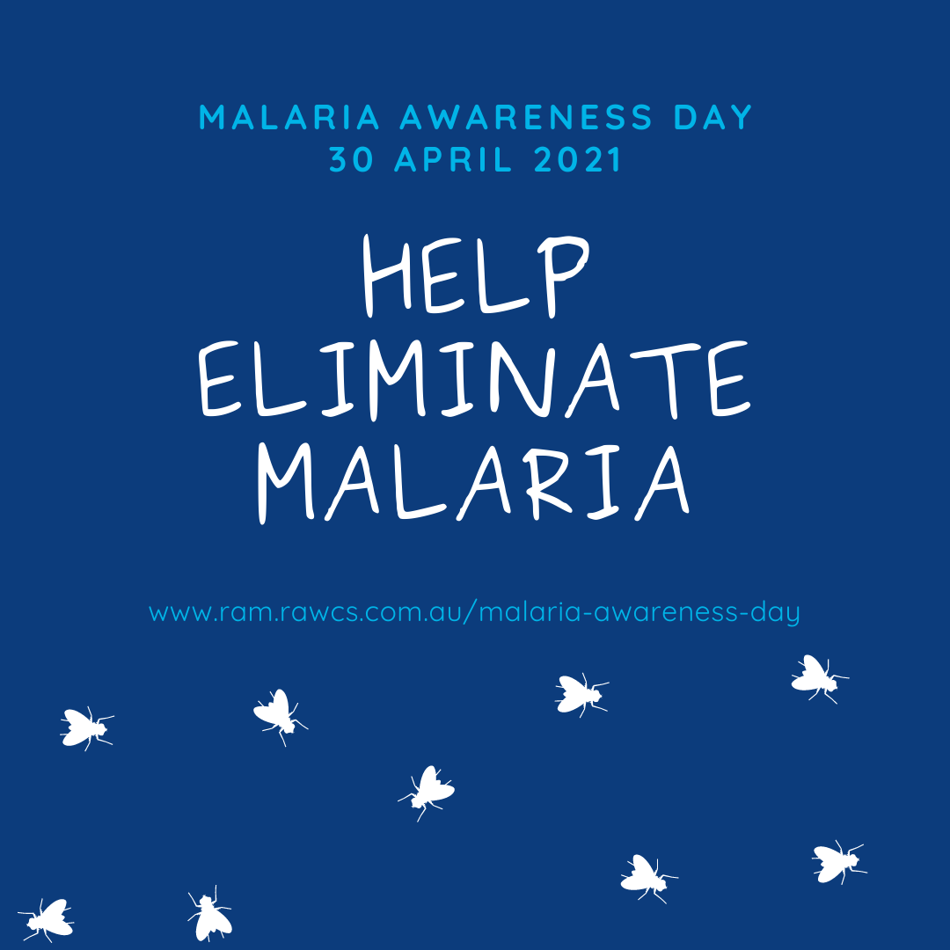
Malaria Awareness Day 2021
World Malaria Day, which takes place on 25 April each year, is an internationally recognized day, highlighting the global efforts to control malaria and celebrating the gains that have been made. Since 2000, the world has made historic progress against malaria, saving millions of lives. However, half the world still lives at risk from this preventable, treatable disease. In Australia, Malaria Awareness Day is observed on 30 April each year, in conjunction with World Malaria Day on 25 April.

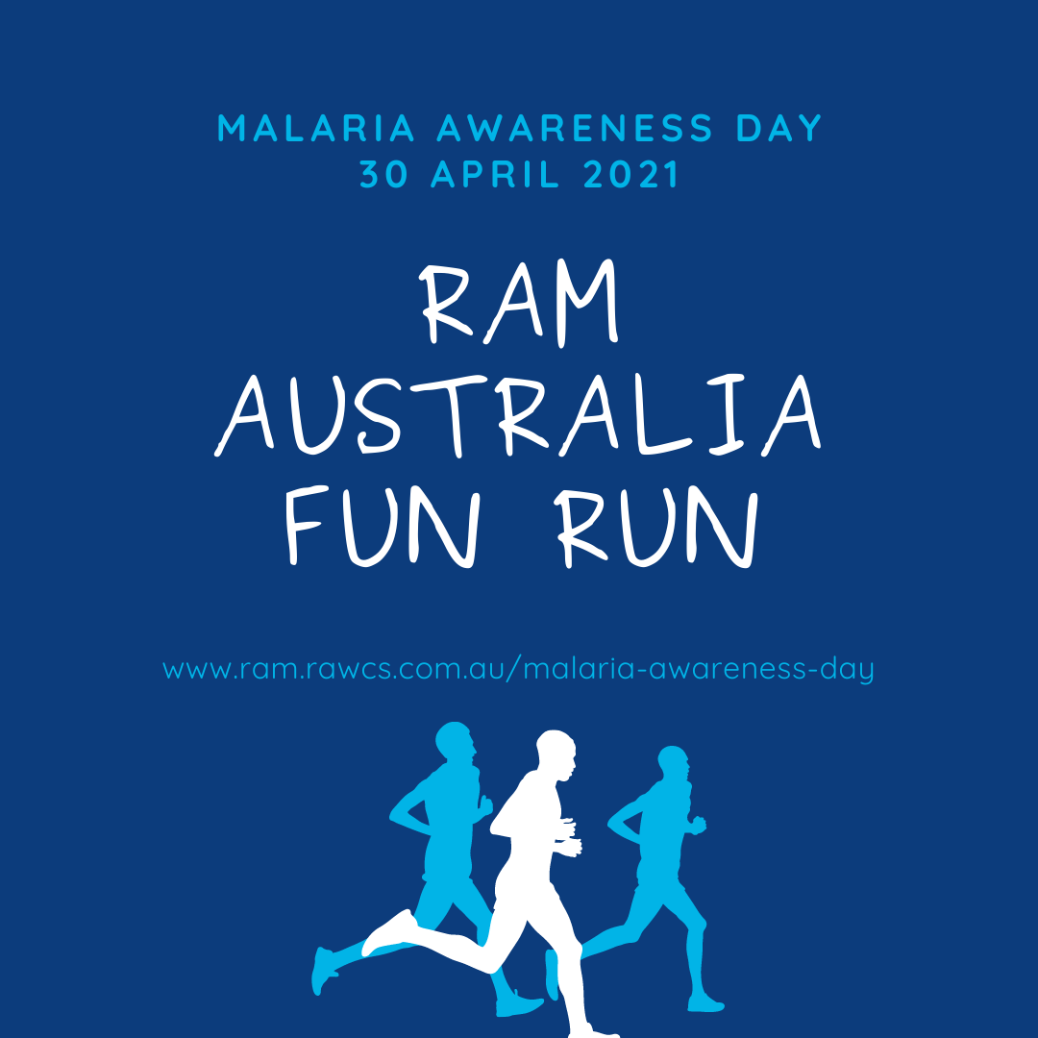
Covid-19 has shown us we must urge greater investment in building and supporting resilient health systems to protect and advance progress against existing infectious diseases like malaria and be prepared to effectively address new outbreaks like COVID-19.

Over the last 2 decades, there has been a period of unprecedented success in malaria control that saw 1.5 billion cases and 7.6 million deaths averted. But each year, more than 400 000 people die of malaria – a preventable and treatable disease. An estimated two thirds of deaths are among children under the age of five. And in 2019, 409 000 people died of malaria.

So, in 2021, we are hosting a fun, safe and virtual event that challenges you to walk, swim, or ride 4km on Malaria Awareness Day to represent the over 400,000 lives lost to malaria each year. You can sign up and donate on our website at https://ram.rawcs.com.au/malaria-awareness-day—ask your friends to get involved too, or donate to support you.
We are asking you to take a photo of yourself doing the challenge (or a selfie) so that we can share on our social media.
We want to raise $100,000 for projects in the upcoming year, so we are challenging each District to raise $5,250. Help us reach our goal!

KEY MESSAGING
Across our social media, the following are the key messages we want to send. Please share them on your personal social media accounts and on other Rotary accounts like Rotary District Facebook pages. More from World Malaria Day (25 April) can be found here: https://spark.adobe.com/page/upCrp31Xs3YSS/.
Theme: Zero Malaria - Draw the Line Against Malaria
Hashtags: #MalariaAwarenessDay, #WorldMalariaDay, #ZeroMalariaStartswithMe
*Covid-19 has shown us we must urge greater investment in building and supporting resilient health systems to protect and advance progress against existing infectious diseases like malaria and be prepared to effectively address new outbreaks like COVID-19.
Malaria Awareness Day aims to highlight the global efforts to end malaria and celebrate the gains that have been made. Since 2000, the world has made historic progress against malaria, saving millions of lives. However, half the world still lives at risk from this preventable, treatable disease, which costs a child’s life every two minutes.
Suggested captions:
This #MalariaAwarenessDay, we celebrate that more countries than ever before are on the cusp of elimination! 🦟🌍 #ZeroMalaria starts with all of us, and with continued leadership, more funding and increased innovation, we can – and must – end malaria once and for all.
Malaria and now COVID-19 has stopped us from attending school, work and building a future. Let's #DrawTheLine against malaria and end it within a generation 🦟
Thanks to global efforts, since 2000 we have seen 7.6m lives saved and 1.5bn cases prevented 🙌🏿🙌🏾🙌🏽🙌🏼🙌🏻 COVID-19 has made the fight to end malaria harder, but we can't stop now. Let's #DrawTheLine and ensure no one is left behind ➡️ ram.rawcs.com.au
We are the generation that can end malaria 🚫🦟 By fighting this deadly disease we strengthen our health systems 🏥 and create a world that is safer for everyone. Join us in finishing the work in our partner countries this #MalariaAwarenessDay ➡️ ram.rawcs.com.au
25 countries have the ability to reach #zeromalaria by 2025! 🎉 Now, more countries than ever before are closer to elimination, so it’s crucial we keep the momentum going 🦟 ram.rawcs.com.au
MALARIA, WE'RE TOO STRONG FOR YOU!

